1. **What is the total amount each customer spent at the restaurant?**

select sal.customer_id, sum(men.price) as spending

from sales sal

join menu men

on sal.product_id = men.product_id

group by sal.customer_id

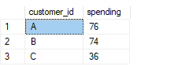

**2. How many days has each customer visited the restaurant?**

select customer_id, count(distinct order_date) as [Total Kunjungan]

--hanya munculin 1 data per kolom nya (jadi klo sehari ada 2 orderdate yg ditampilkan hanya 1 karena pakai 'distinct')

from sales

group by customer_id

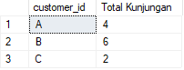

**3. What was the first item from the menu purchased by each customer?**

(SUB QUERY)

select sal.customer_id, men.product_name as pembelianpertama

from sales sal

join menu men

on sal.product_id = men.product_id

where sal.order_date = (select min(order_date)

from sales)

group by sal.customer_id, men.product_name

order by sal.customer_id

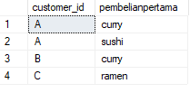

(CTE)

WITH table_filter as

(select sal.customer_id, men.product_name, sal.order_date,

row_number () over (partition by customer_id order by order_date asc) as pembelianpertama

from sales sal

join menu men

on sal.product_id = men.product_id

group by sal.customer_id, men.product_name, sal.order_date)

SELECT *

from table_filter

where pembelianpertama = 1

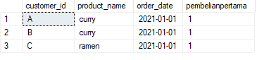

**4. What is the most purchased item on the menu and how many times was it purchased by all customers?**

#1 kalau mau lihat total sales semua produk tiap customer

SELECT customer_id, purchase_count, product_name

FROM (

SELECT customer_id, product_name, COUNT(*) AS purchase_count,

DENSE_RANK() OVER (PARTITION BY customer_id ORDER BY COUNT(*) DESC) AS rnk

FROM sales

join menu

on sales.product_id = menu.product_id

GROUP BY customer_id, product_name

) ranked

WHERE rnk = 1

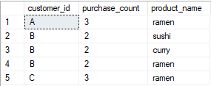

#2 kalau mau cari produk dengan sales terbanyak, dan brp sales produk tsb dari tiap customer

select sal.customer_id, men.product_name, count(sal.product_id) as purchase_count

from sales sal

join menu men

on sal.product_id = men.product_id

where sal.product_id = (

select max(product_id) from sales)

group by sal.customer_id, men.product_name

order by sal.customer_id

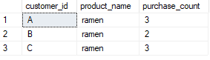

**5. Which item was the most popular for each customer?**

select sal.customer_id, men.product_name

from sales sal

join menu men

on sal.product_id = men.product_id

where sal.product_id = (

select max(product_id) from sales)

group by sal.customer_id, men.product_name

order by sal.customer_id

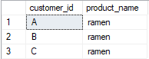

**6. Which item was purchased first by the customer after they became a member?**

select mem.customer_id, mem.join_date, men.product_id, men.product_name as [pembelian pertama]

from members mem

join sales sal

on mem.customer_id = sal.customer_id

join menu men

on sal.product_id = men.product_id

where sal.order_date = (

select min(join_date)

from members)

group by mem.customer_id, mem.join_date, men.product_id, men.product_name

order by mem.customer_id



***(ini untuk nampilin semua pembelian setelah jadi member)***

select mem.customer_id, mem.join_date, men.product_id as [pembelian setelah jadi member], men.product_name as [nama menu]

from members mem

join sales sal

on mem.customer_id = sal.customer_id

join menu men

on sal.product_id = men.product_id

where sal.order_date > = mem.join_date

group by mem.customer_id, mem.join_date, men.product_id, men.product_name

order by mem.customer_id

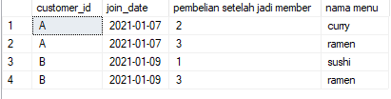

**7. Which item was purchased just before the customer became a member?**

select mem.customer_id, sal.order_date, men.product_id as [pembelian sebelum jadi member], men.product_name as [nama menu]

from members mem

left outer join sales sal

on mem.customer_id = sal.customer_id

join menu men

on sal.product_id = men.product_id

where sal.order_date < mem.join_date

group by mem.customer_id, sal.order_date, men.product_id, men.product_name

order by mem.customer_id

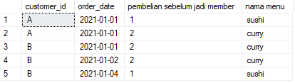

**8. What is the total items and amount spent for each member before they became a member?**

with table_filter as (

select mem.customer_id, sal.order_date, sum(men.price) as harga

from members mem

left outer join sales sal

on mem.customer_id = sal.customer_id

join menu men

on sal.product_id = men.product_id

where sal.order_date < mem.join_date

group by mem.customer_id, sal.order_date, men.price

)

select customer_id, sum(harga) as [Total Spending]

from table_filter

group by customer_id

order by customer_id

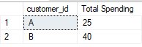

**9. If each $1 spent equates to 10 points and sushi has a 2x points multiplier - how many points would each customer have?**

with table_filter as (

select sal.customer_id, men.product_name, men.price, count(sal.product_id) as penjualan,

case

when men.product_name = 'sushi' then (men.price * 20 * count(sal.product_id))

Else (men.price * 10 * count(sal.product_id))

END AS points

from sales sal

join menu men

on sal.product_id = men.product_id

group by sal.customer_id, men.price, men.product_name

)

select customer_id, sum(points) as [Points Achieved]

from table_filter

group by customer_id

order by customer_id

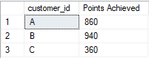

**10. In the first week after a customer joins the program (including their join date) they earn 2x points on all items, not just sushi, how many points do customer A and B have at the end of January?**

with table_filter as (

select mem.customer_id, mem.join_date, men.price, count(sal.product_id) as penjualan, sal.order_date,

case

when (sal.order_date > = mem.join_date) then (men.price * 20 * count(sal.product_id))

Else 0 END AS points

from sales sal

join menu men

on sal.product_id = men.product_id

join members mem

on mem.customer_id = sal.customer_id

where sal.order_date > = mem.join_date

group by mem.customer_id, mem.join_date, men.product_id, men.price, sal.order_date

)

select customer_id, sum(points) as [Points Achieved]

from table_filter

where order_date < '2021-02-01'

group by customer_id

order by customer_id

